Base station issues
-OMMO service show error and BST show orange LED, Plug-in & out the USB connector repeatedly.
-Serial number B1181(FW v7010), From SZ sales team.
-3 meters USB cable type-A to type-C.
-SIU 12542(FW v7012)
-ommo_service_v0.21.1

1. Test on the laptop DELL precision 7710, Windows 10
- Plug-in & out 20 times for USB of the BST, before and after test item 2, Always working fine.
2. Test on the laptop ThinkPad R14 Gen 2, Windows 11
- Plug-in & out 20 times for USB of the BST, The following three issues occurred:
a. BST showed error on ommo service and BST showed orange LED.
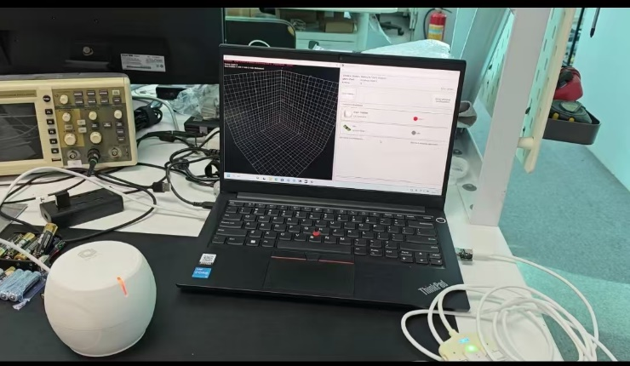
b. BST showed error on ommo service and BST showed blue LED.
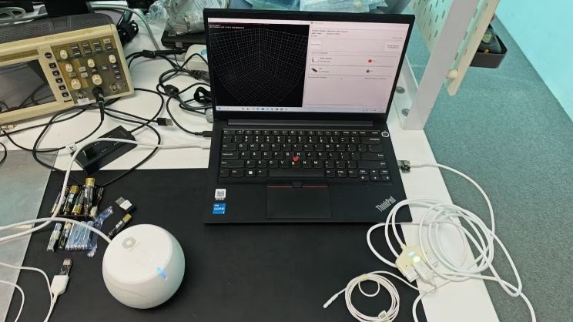
c. BST was running, SIU showed IDLE on ommo service and showed blue LED.
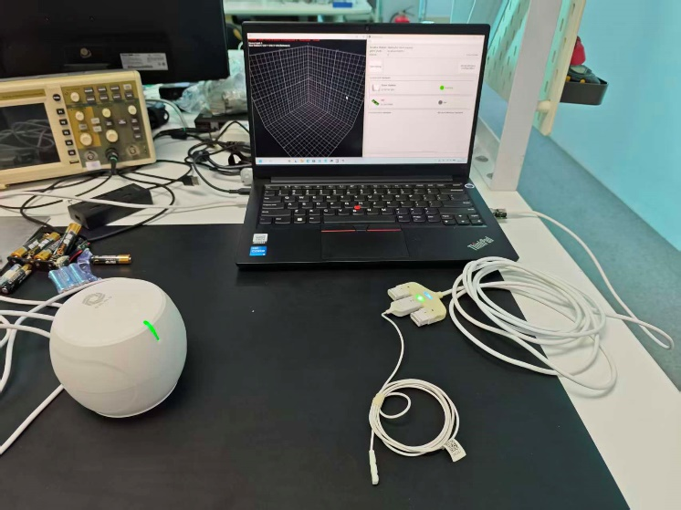

3. Added a switch to control the D+ and D-.
- After plug in the USB, Switching the D+ and D- signals quickly,
- This can easily happen on both computers, BST showed error on ommo service and BST showed orange LED.
